Gp Capt Rakhi Malhotra
Senior Advisor Medicine & Endocrinologist, CHAFB

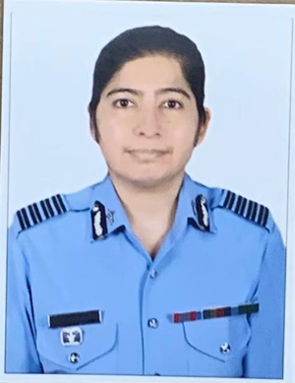

Academic credentials-
MBBS – AFMC Pune
MD Medicine- Delhi University
DM Endocrinology AIIMS, New Delhi

Publications and awards-
18 publications (National – 06, International -12)

Academic awards:
Chief of Naval Staff Bronze medal in Pathology
AV Gandhi award and Gold medal by the Endocrine society of India for best research work in Endocrinology- 2019

Commendations : AOC IN C commendation in 2012
Areas of research interest
Pediatric Endocrinology, Metabolic bone disease

