Dr. Pritam Priyansu Purohit
Medicine Department, Command Hospital, Pune | Ph: +91 9545253783 | prriyansu@gmail.com 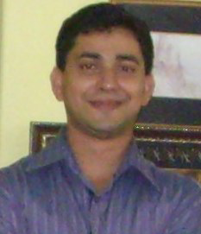

EDUCATION

Subspeciality Residency In Geriatric Medicine, CMC Vellore, MGR University Jul’21-Jul’23

MD, Medicine, AFMC Pune: MUHS Nashik Jun ‘14 – Jun‘17

Bachelor of Medicine and Bachelor of Surgery, AFMC, MUHS, Pune Jul ‘04 – Feb‘10
- Distinction in Ophthalmology, 2007

DOCTORAL PROJECT, MD, Medicine
Aquaporin4 antibody positivity in acquired CNS demyelination Oct ’14 – Mar’16
- Consistency: Results of the research were consistent with studies done elsewhere in the world.
- Awarded best Thesis award at IARET conference of Rheumatology at Bengaluru, Dec 2017.

WORK EXPERIENCE& INTERNSHIP

Medical Officer, Indian Army Feb‘10 – May‘14
- Posted and worked in remote areas of Jammu & Kashmir managing all kinds of cases with minimal resources.
- Awarded GOC in C commendation 2014

Intern, Military Hospital, Agra Feb ’09 – Feb ‘10
• Successfully completed one year of internship.

Classified Specialist Medicine and Trained in Geriatrics, Command Hospital Pune Jul 23-Till date
Graded /Classified Specialist Medicine, Military Hospital, Gopalpur May’19-Jul’21
Graded Specialist Medicine Military Hospital, Alwar May ’17-May’19

