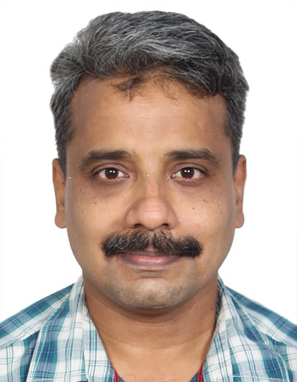
Curriculum Vitae

1. Name: Col (Dr) Kompella Kiran Kumar

2. Date of Birth/Sex : 28 Sept 1978/Male

3. Academic Qualifications
MBBS - 2001 ( AFMC –Pune)
MD (Gen Med)- 2011 (AFMC –Pune)
DNB (Gen Med)- 2015
National Board Fellowship in Infectious Diseases (Apollo Hospital, Greams Road Chennai) 2018-2020

4. Date of commission/Service : 14 Aug 2001 in AMC
>20yrs service in Army Med Corps, with 1.5yr stint in Indian Level III field Hospital under UN , MONUSCO as a Physician at Goma, Democratic Republic of Congo.

5. Present Designation : Physician to the Hon President of India
Sr Advisor Medicine and Infectious Diseases
Army Hospital Research & Referral, Delhi Cantt -10

6. Membership
Life time Member of Clinical Infectious Diseases Society –India
Life time Member of API –Membership no L 20105
Life time Member of AIDS society of India
Life time Member of Marine Medical Society India
Life time Member of Bombay Medical Congress.

7. Publications in Yr 2023

Multicenter Case-Control Study of COVID-19-Associated Mucormycosis Outbreak, India

Valliappan Muthu, Ritesh Agarwal, Shivaprakash Mandya Rudramurthy, Deepak Thangaraju, Manoj Radhakishan Shevkani, Atul K Patel, Prakash Srinivas Shastri, Ashwini Tayade, Sudhir Bhandari, Vishwanath Gella, Jayanthi Savio, Surabhi Madan, Vinay Kumar Hallur, Venkata Nagarjuna Maturu, Arjun Srinivasan, Nandini Sethuraman, Raminder Pal Singh Sibia, Sanjay Pujari, Ravindra Mehta, Tanu Singhal, Puneet Saxena, Varsha Gupta, Vasant Nagvekar, Parikshit Prayag, Dharmesh Patel, Immaculata Xess, Pratik Savaj, Naresh Panda, Gayathri Devi Rajagopal, Riya Sandeep Parwani, Kamlesh Patel, Anuradha Deshmukh, Aruna Vyas, Srinivas Kishore Sistla, Priyadarshini A Padaki, Dharshni Ramar, Saurav Sarkar, Bharani Rachagulla, Pattabhiraman Vallandaramam, Krishna Prabha Premachandran, Sunil Pawar, Piyush Gugale, Pradeep Hosamani, Sunil Narayan Dutt, Satish Nair, Hariprasad Kalpakkam, Sanjiv Badhwar, Kiran Kumar Kompella, Nidhi Singla, Milind Navlakhe, Amrita Prayag, Gagandeep Singh, Poorvesh Dhakecha, Arunaloke Chakrabarti PMID: 36573628 PMCID: PMC9796192 DOI: 10.3201/eid2901.220926.

Catheter related atrial thrombus caused by Abiotrophia defectiva: A case series and review of literature Gerry George Mathew , Kiran Kumar Kompella Rajamahesh Jayabalan, Venkatesh Rajkumar PMID: 37464787 DOI: 10.1177/11297298231188926

Awards and Honours :
Physician to the Honorable President of India wef March 2023
Recipient of Vice Chief of Army Staff Commendation Card -2021
Recepient of SFC C-in-C Commendation Card - 2022

Registration
Registered with Maharashtra Medical Council
MMC 2002082901

Date 01 Sept 2023
Place New Delhi

