CURRICULUM VITAE

PAVITRA MANU DOGRA, MD, DM, FISN, FASN, FRCP Edin
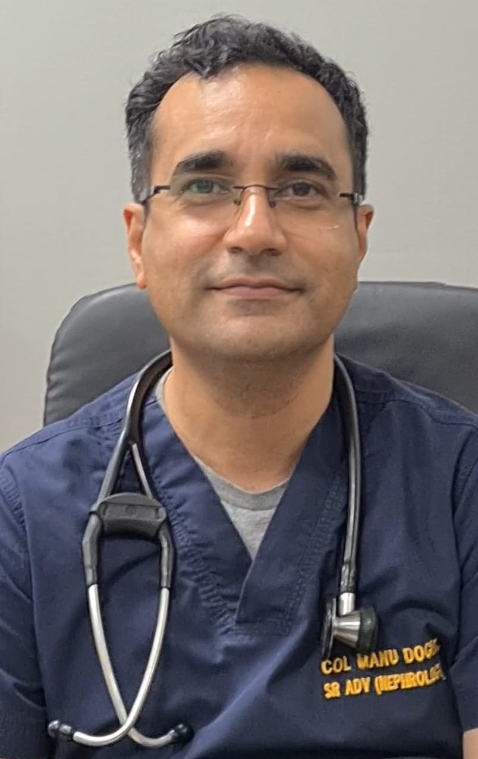

APPOINTMENT : Col Pavitra Manu Dogra
Senior Advisor (Medicine & Nephrology)
Dept of Nephrology
Army Hospital (R&R), Delhi Cantt-110010
DATE OF BIRTH : 24 April 1974
TELEPHONE NO. : 9051144883
EMAIL : dodgemanu@gmail.com

MEDICAL ACADEMIC QUALIFICATIONS
- MBBS : Armed Forces Medical College/Pune University (1996)
- MD (Medicine): Armed Forces Medical College/Pune University (2004)
- DM (Nephrology): All India Institute of Medical Sciences (2011)

FELLOWSHIPS : 1. FASN: Fellowship of American Society of Nephrology
2. FISN: Fellowship of Indian Society of Nephrology
3. FRCP (Edin): Fellowship of Royal College of Physicians (Edinburgh)

HONOURS AND AWARDS
- Chief of Army Staff Commendation (2001)
- United Nations Commendation (2006)

EXTRAMURAL DUTIES IN NEPHROLOGY
- Formerly Director, Armed Forces Organ Retrieval and Transplantation Authority (AORTA)
- Nephrology Expert for AIIMS Nagpur Staff Selection committee (2020-22)
- External Examinership for Nephrology (Final) examinations for DM and DrNB

OFFICE BEARER IN NATIONAL SOCIETIES
- Treasurer, Indian Society of Nephrology- Northern Zone (Oct 2018 onwards).
NEPHROLOGY SOCIETY MEMBERSHIP
- National societies:
  - Indian Society of Nephrology
  - Peritoneal Dialysis Society of India
  - Indian Society of Organ Transplantation
  - Armed Forces Medical Research Committee
  - Delhi Nephrology Society
  - Indian Society of Nephrology-Northern zone
  - Indian Academy of Nephrology
- International societies:
  - American Society of Nephrology
  - European Renal Association- European Dialysis and Transplant Association
  - International Society of Nephrology
  - Royal College Of Physicians Edinburgh

AREAS OF INTEREST
- Peritoneal dialysis – Insertion techniques and survival outcomes
- Interventional Nephrology
- Renal Transplantation

PUBLICATIONS: 32 (International and National)
RECENT PUBLICATIONS (Jan – Jun 2023)
- Sood V, Mishra K, Bahl R, Singhal G, Dogra PM, Suman P, Singh V. Hyperviscosity syndrome complicating immunoglobulin G myeloma-Cognisance of early plasmapheresis is crucial. Semin Dial. 2023 Mar; 36(2):175-177. doi: 10.1111/sdi.13135. Epub 2022 Dec 21. PMID: 36541085.

- Singh B, Dogra PM, Sood V, Singh V, Katyal A, Dhawan M, et al. Spectrum, Outcomes, and Mortality Predictors of Acute Kidney Injury among Non-COVID-19 Patients during COVID-19 Pandemic: Data from Four Intensive Care Units. Indian J Crit Care Med 2023;27(2):119–126.

- Singh V, Dogra PM, Singh P, Ghosh I, Singhal G. Renal limited sarcoidosis presenting with acute kidney injury. Medical Journal Armed Forces India, 2023 (in press).

