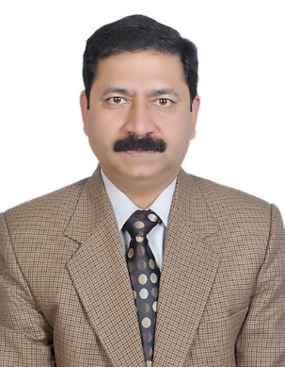
BRIG PK SHARMA
Consultant (Med & GE)
CH(EC)
Alumnus of AFMC (MBBS, MD)
DM(GE)-AIIMS, New Delhi
Contributions to textbooks & Updates in Medicine & Gastroenterology
Reviewer for Journals in Medicine & Gastroenterology
Published 11 International and 16 National original research papers.
Awards & Felicitations:Young Investigator ISG(2006);COAS Commendation(2011);FICP(2014)

