CV – Wg Cdr (Dr) Rajeev Chauhan
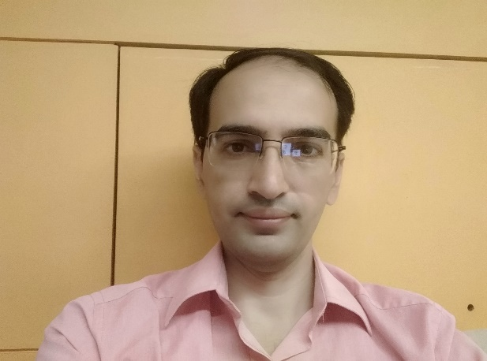

Present Position |  | Classified Specialist (Medicine) and Cardiologist, Command Hospital (Air Force), Bangalore
Past Appointment |  | Clinical Tutor, Dept of Medicine, AFMC  Physician at Air Force Hospital Amla
Education / Training |  | College / University
MBBS |  | AFMC Pune, MUHS Nashik
MD (Medicine) |  | AFMC Pune, MUHS Nashik
DM (Cardiology) |  | PGIMER, Chandigarh
Interventional Procedures Performed |  | More than 1000 interventional procedures of Angiography, Angioplasty, CHIP Procedure, Pacemakers,ICD etc.
PUBLICATIONS |  |  | 15 National & International publications

Publications
1 | Behera V, Behera MK, Chauhan R, Nair V. Duchenne muscular dystrophy. BMJ Case Rep. 2014 Jun 10;2014. pii: bcr2014205296. doi: 10.1136/bcr-2014-205296. PubMed PMID: 24916987.
2 | Behera V, Chauhan R, Sinha S, Nair V. Anaphylactic Shock Secondary to Intravenous Iron Sucrose in Chronic Kidney Disease. Indian J Hematol Blood  Transfus. 2015 Sep;31(3):391-3. doi: 10.1007/s12288-014-0475-0. Epub 2014 Nov 18.PubMed PMID: 26085728; PubMed Central PMCID: PMC4465511.
3 | Chauhan R, Mendonca S. Adequacy of twice weekly hemodialysis in end stage renal disease patients at a tertiary care dialysis centre. Indian J Nephrol. 2015 Nov-Dec;25(6):329-33. doi: 10.4103/0971-4065.151762. PubMed PMID: 26664206; PubMed Central PMCID: PMC4663768.
4 | Sashindran VK, Chauhan R. Antiretroviral therapy: Shifting sands. Med J Armed Forces India. 2016;72(1):54-60. doi:10.1016/j.mjafi.2015.12.002
5 | Krishna Santosh Vemuri, Pruthvi C. Revaiah, Dinakar Bootla, Rajeev Chauhan, Krishna Prasad Nevali, Aditya Jandial, Man Updesh Singh Sachdeva, Dushyant Singh, Manoj Kumar Rohit, .Early T Cell Precursor Leukemia Presenting With Superior Vena Cava  Syndrome and Cardiac Tamponade.JACC: CARDIOONCOLOGY.VOL. 2, NO. 5, 2020
6 | Krishna Prasad, Himanshu Gupta, Bhupendra Kumar Sihag, Dinakar Bootla, Prashant Panda, Arun Sharma, Rajeev Chauhan, Atit Gawalkar, Neelam Dahiya, Submitral aneurysm of varied aetiologies: a case series, European Heart Journal - Case Reports, Volume 5, Issue 2, February 2021, ytab066, https://doi.org/10.1093/ehjcr/ytab066
7 | Yash Paul Sharma, Prashant Panda, Rajeev Chauhan* , Krishna Prasad, Jyothi Vijay. Combining reverse nano-crush and stentboost technique to optimize  outcome for bifurcation stenting.Interv. Cardiol. (2021) 13(2), 274-277.ISSN 1755-5302
8 | Swamy AJ, Chauhan R*, Keshavamurthy G. Primary percutaneous coronary intervention during the COVID-19 pandemic: Recalibrate, restart and relearn. Med J Armed Forces India. 2021 Jul;77(Suppl 2):S520-S521. doi: 10.1016/j.mjafi.2021.06.008. Epub 2021 Jul 26. PMID: 34334925; PMCID: PMC8313070.
9 | Rupesh Kumar , Vikram Halder, Yamasandi Siddegowda Shrimanth, Atit A Gawalkar, Rajeev Chauhan, Krishna Prasad, Manoj Kumar Ukadbhai Rohit, Sujithareddy Karri, Sheenam Walia, Avneet Singh.Acquired cyanosis secondary to RVOT obstruction due to pacemaker lead prolapse and vegetation in a child with ASD. Journal of Cardiology Cases. 2021.Accepted 16 September 2021.https://doi.org/10.1016/j.jccase.2021.09.014
10 | Kaur Navjyot, Chauhan Rajeev, Swamy Ajay. (2021). Rotablation: A single centre experience. Indian Heart Journal. 73. S45-S46. 10.1016/j.ihj.2021.11.087.
11 | Chauhan Rajeev, Swamy Ajay, Kaur Navjyot , Bhat Keshavamurthy. (2021). Clinical and angiographic outcomes for left main PCI. Indian Heart Journal. 73. S84-S85. 10.1016/j.ihj.2021.11.172.
12 | Kumar R, Chadha D, Chaddha A, Chauhan R, Singh N, Kamal P, Mishra A, Kaur N. The Safety and Long-Term Efficacy of Carotid Artery Stenting: An All-Comers Registry. Cureus. 2022 Nov 30;14(11):e32060. doi: 10.7759/cureus.32060. PMID: 36600837; PMCID: PMC9800945.
13 | Chauhan R, Otaal PS. Intra-Aortic Balloon Pump During Percutaneous Coronary Intervention in ST-Elevation Myocardial Infarction With High Thrombus Burden and Cardiogenic Shock. Cureus. 2023 Jan 25;15(1):e34188. doi: 10.7759/cureus.34188.

AFMRC Project- Ongoing-01 (2022-24)
Comparison between Resting full cycle ratio (RFR) versus fractional flow reserve (FFR) on coronary lesions with intermediate significance

